# Visualization using Shiny R

Options to see data sets and summary of the datasets used

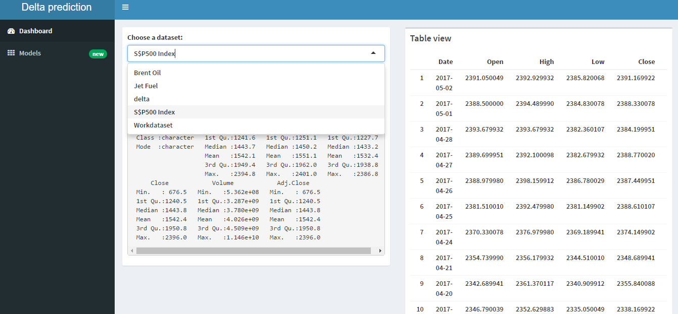

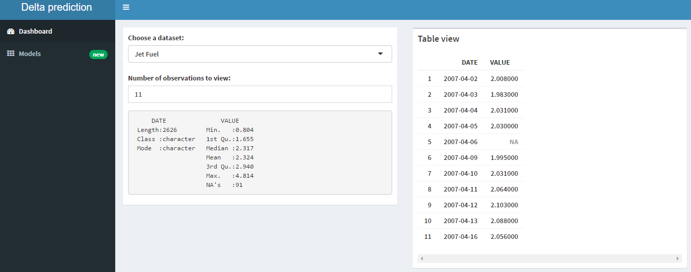

Options to see models and their output

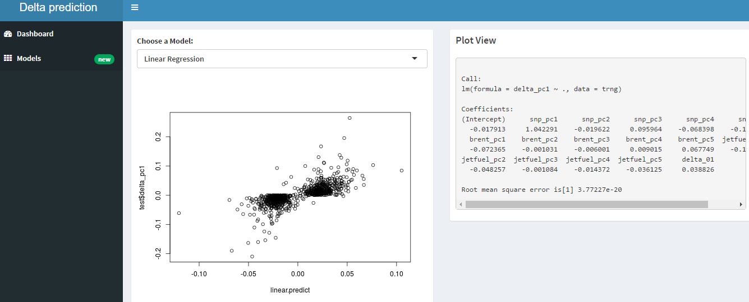

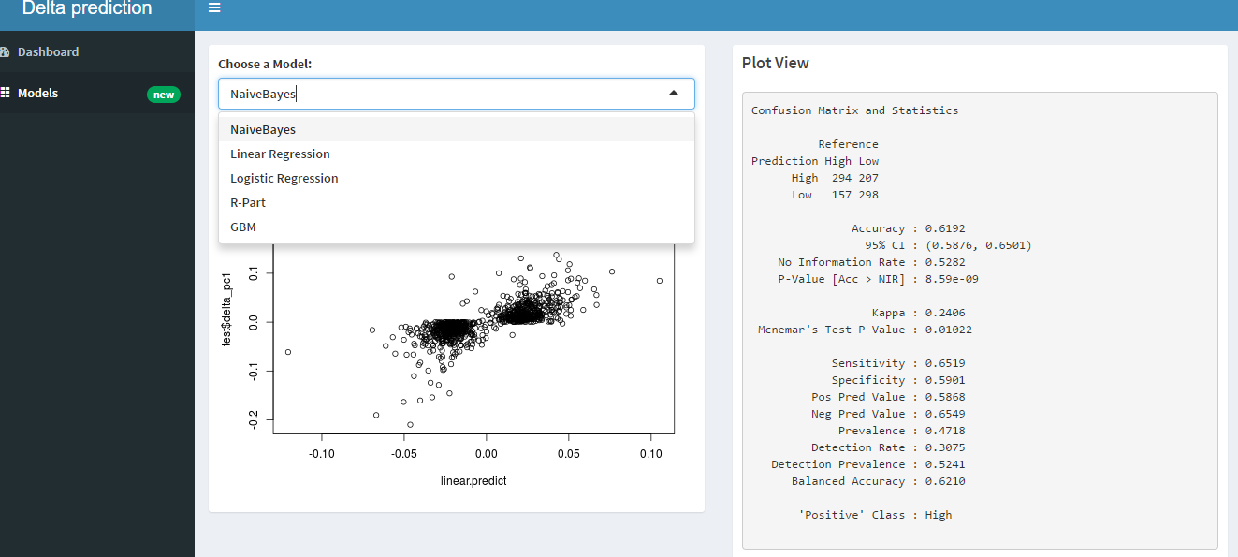

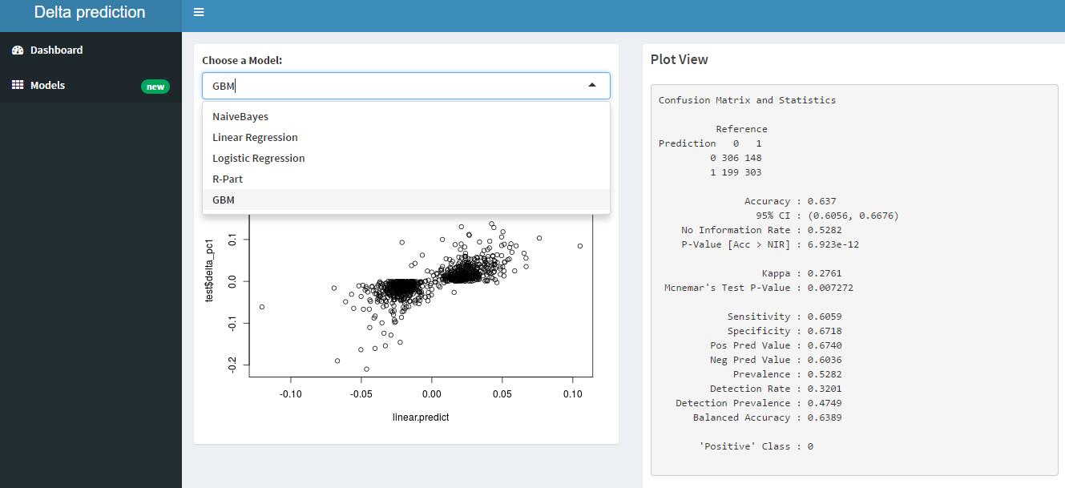

I am continuing working on it to make it more interactive and adding more features like the correlation matrix between variables which we transformed from our base data.

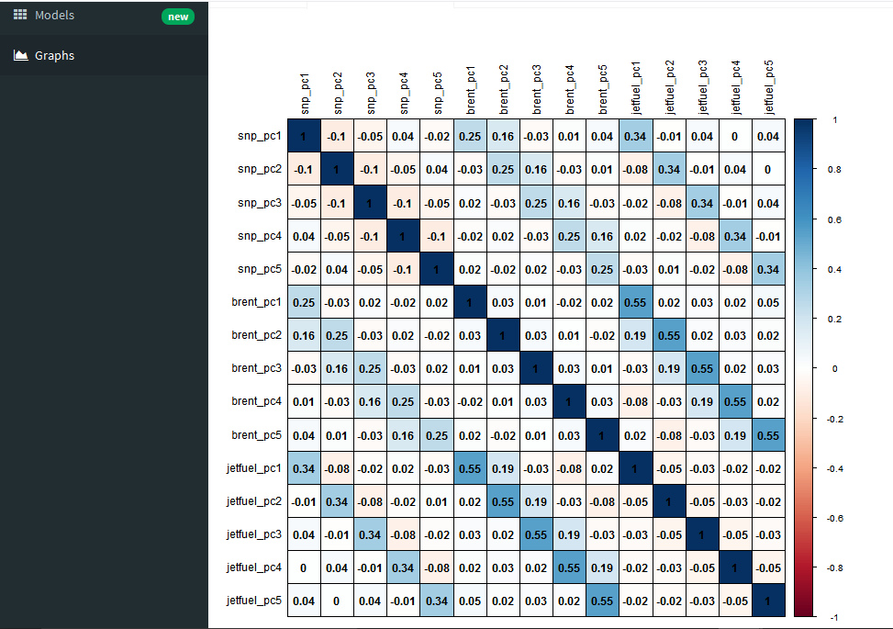

Thanks,

Swapnil Awasthi